Reflection Work Creative Technology

**Anna Bezani**

Monday 10th of October, the new module called Creative Technology started at 9.00 am and I will be honest the first couple of hours I felt confused and terrified. At the time, I was felling that I was walking blind. For first time in my life, I heard about the open source Arduino. However, the following days everything was becoming clearer. Professor Martin Skelly and Jon Rogers were really supportive, helping each of us individually and showing us that Arduino is easier than we first thought. For me, the helpful element to begin with was how passion they were for the studio and how they were trying to highlight this to us. The first assignment was to develop different ideas about a connected home. From these ideas, we will have to choose one as our last final product due at the end of the fourth week.

I spent some time brainstorming and started to understand how the Arduino software worked. In this week, I developed three basic ideas, which would be able to help people. The first one was a product that was able to alert people when their pasta was al dente and ready to serve, as all too often people over do their pasta. Having analysed my idea, I thought that this wasn’t demonstrating how creative or innovative I could be. It didn’t represent me, and my wish to combine technology with helping people. This led me to think of the idea that I called “Magic Pillow”.

Magic Pillow was a product that could help autistic people. The main idea was to support them in waking up without feeling anxious or angry. Autistic individuals tend to be more sensitive to loud disruptive noises, such as alarm clocks. As a result I combined using Arduino a specific calm noise and vibration to be used as an alarm. This idea consequently led me to think about the different ways that individuals with a disability require different things from their home. I thought about how best to support the needs of an individual through connected home that would not be found on the market.

Research in different supportive methods can be quite scarce, especially for less common disabilities such as sever dyspraxia. After sharing my idea with Professor John Rogers, he helped to be more accurate and showed a new way to combine Arduino and Bare Conductive. This simplified my idea and gave it more practical application for disabilities in day to day life improve the quality of life as well as day to day living. Sharing ideas with PhD students gave more knowledge of how I will continue to develop my idea.

After the end of this week, I developed greater skills in Arduino, which I can now add to my repertoire of computing skills. On reflection, I understand how my levels of stress at the beginning of the week impacted my creativity as I lost precious time. Understanding my stress better would have enabled to have better ideas earlier in the week.

After the first week’s introduction and first meet with Arduino, the pieces about technology, prototypes and connected home started to make more sense. Our goal during the second week was to develop three new ideas, where by one would be chosen to develop further as our final prototype. I found myself reluctant to move away from the idea of creating something that could help those in need and therefore concentrated on thinking about symptoms of different disabilities and how Arduino could compensate for those symptoms.

As a result I came up with an idea that could help deaf people. The product could notify them when someone was ringing the doorbell. Or notify them when something was happening in their environment that they wouldn’t be able to hear. For example, the product could be a bracelet that would vibrate when either the doorbell/phone was ringing. Current products use lights systems to alert deaf people, which may go unseen by the individual if they’re busy doing something else. The benefit of the vibrating bracelet is that it would be able to alert any individual, regardless if they were busy. Having spoken to Professors Martin and Fraser, I realized that the idea of a bracelet was not so original.

After my conversation with them about my ideas, they asked me why I am not continuing with the dyspraxia project and if there was anything that worried me about that . My answer was that I didn’t have the knowledge that I needed to connect all these devices and develop the prototype that I had in my mind. After their advice and finally understanding exactly what I had to do, I decided that I will concentrate on my dyspraxia project. I started by researching more about it and gathered the information I needed. I joined a forum for dyspraxic people and gave an explanation of my assignment.

From the information that I gathered, I established that one of the main symptoms of dyspraxia was poor organizational skills. This would affect their daily routine, and make it difficult if there were any changes or disruptions. For example, on the forum, there was a gentleman who was moving out of his house and couldn’t figure out how to organise his belonging once he had unpacked the boxes. He mentioned how frustrating it was to rely on others as this sort of organizational issue occurred.

Furthermore, I established from the forum that any product that would be of assistance must be waterproof, rechargeable and remind them to collect their important items before leaving the house e.g. keys, wallet and shopping list. To combat poor organizational skills, individuals were using Dictaphones and assistive technology e.g. mind mapping software. Therefore, my final product needed to incorporate the benefits of the previously mentioned items.

The third week, I started developing the prototype by first creating a moodboard shown in Figure 1. Combining the information presented on my moodboard allowed me to understand how I want my prototype to look like and how the dyspraxics can use it.

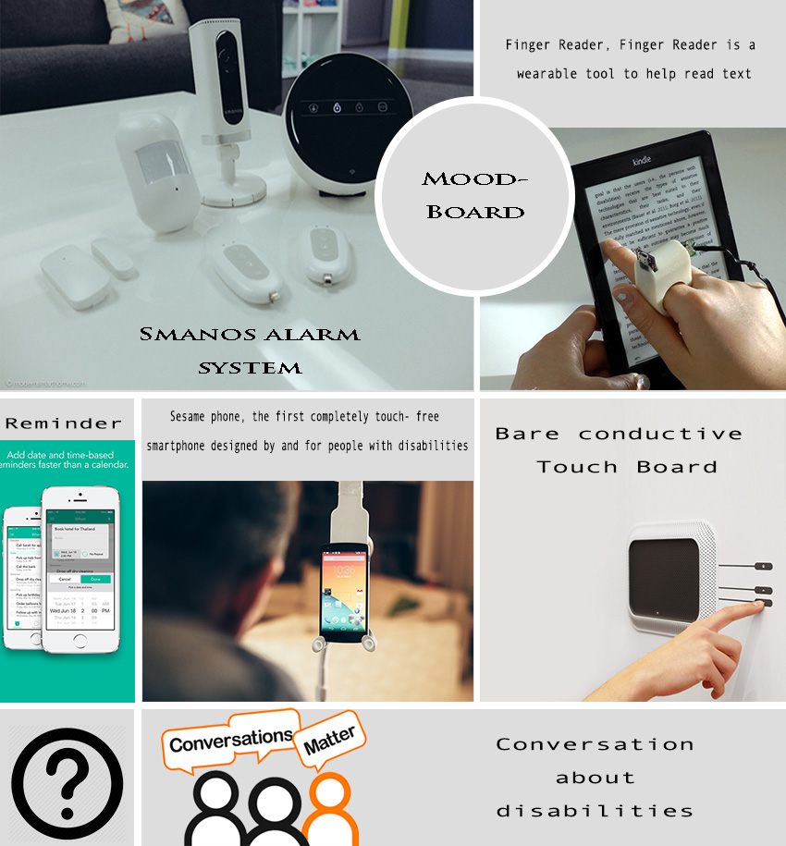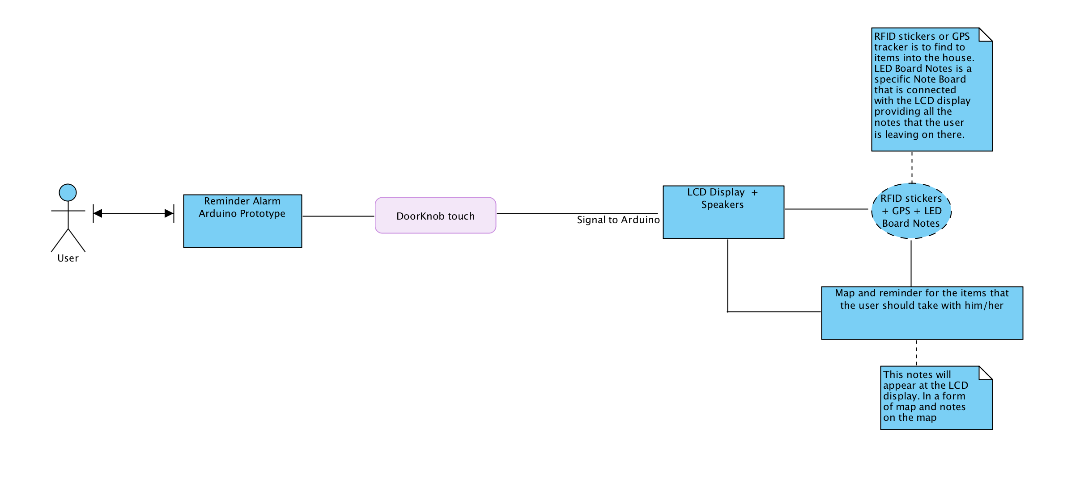

Figure 1: MoodBoard

The next step was to design the user journey using Visual Paradim shown in the Figure 2. The image shows the individual interacts with the product and the sequence that occurs.

Figure 2: User Journey

Following this, I had to create my personas and scenarios which would provide more information about my final prototype. As a result I came up with two personas and one scenario.



|  |  |
| --- | --- |
| John Smith | |
| **Occupation:** | Financial Analyst |
| **Demographics:** | * 30 years old * Married * Father of one child (Stefany , aged 2 ) * Has a BA in Business Management |
| **Technology Use:** | Basic knowledge. He uses the computer for work and has an iPhone for personal use. When he gets home, he spends about an hour browsing and playing games online. |
| **Key Goals:** | * Knows that he needs a reminder for lists that he always forgets * Keys/ Wallet/ Charger * Something like mind mapping software and Dictaphone |
| **Description:** | John is anxious , disorganized, can be easily frustrated and clumsy. He likes to be organized but sometimes cannot control the dyspraxia and that’s why his wife helps him with his daily planning. However, he doesn’t like it because he feels that he is depend on others. Using mind mapping software and dictaphone helped him but he lost his Dictaphone as a results he is searching for something that cannot be lost and be connected to his daily routine. Using the doorknob alarm makes him feel safer about his personal plans. |
| **We must not** | * Need charger * Only Vision * Complex System |



|  |  |
| --- | --- |
| Zoe Smith | |
| **Occupation:** | PhD Student |
| **Demographics:** | * 28 years old * Single * Has a BA in Psychology * Has a MSc in Human Computer Interaction |
| **Technology Use:** | She is doing her PhD on computing combined with psychology as a result her knowledge is really good. She is working for projects about robotic and prototypes. |
| **Key Goals:** | * Knows that she wants to buy * Keys/ Wallet/ Charger * Something like mind mapping software and Dictaphone |
| **Description:** | Zoe has difficulties to focus, disorganized, can be messy and cluttered. She needs to be more organized for the purchase of her phd degree. Using the doorknob alarm, she feels safe about her daily planning. As a result, she doesn’t have to worry for her important items that she will need during her day |
| **We must not** | * Need charger * Only Vision * Complex System |

# Scenario for Zoe Smith

Zoe is 28 years old, loves computing, loves new technology trends and has really modern house. However, her dyspraxia is frustrated her at her daily things. Doorknob Alarm is helping her before she leaves from her house to take her personal belongings such as wallet, keys, chargers, phone or lists that she wanted to have with her. The most important thing is that it can provide a map and where exactly are the items in the house, giving specific details for the room that she can find them. Another important detail is that the system can read the map and give her the information. As a result, if she doesn’t look at the LCD display she will hear the system telling her about her belongings.